**Task 1 - Autocomplete**

**Task overview**

Create a function that, by a given array of strings, creates an autocomplete dropdown list

* The function takes two parameters:
  + A **selector** that can be any CSS3 selector:
    - By id -#id
    - By class - .class
    - By node type - div
    - Or nested selectors - #this .is a .nested.selector
  + A suggestions array
    - Array of strings
    - **optional**, may not be provided

The following must be implemented:

* Adding a suggestion for each element from the suggestions array
* Entering a string for autocomplete
  + Any suggestion that does not contain the autocomplete string must be hidden
  + When the autocomplete string is empty, all suggestions must be hidden
* Adding a new string for suggestion
  + Clicking the "Add" button, must add the string from the autocomplete to the suggestions
    - If the new suggestion is already contained in the suggestions, skip it
    - A suggestion can be contained only once
* Selecting a suggestion
  + Selecting a suggestion from the suggestions must be filled in the autocomplete input

**Task requirements**

1. Use the HTML from the index.html file
2. Each suggestion must have the following HTML:
3. <li class="suggestion">
4. <a href="#" class="suggestion-link">Apple</a>

</li>

**Solution template and submission:**

* Use the following submission template:

function solve(){

return function(selector, suggestionsArray){

//your code here

};

}

* Submit it in [http://bgcoder.com](http://bgcoder.com/)

**Example usage 1:**

<div class="autocomplete">

<input class="tb-pattern" type="text" />

<a href="#" class="btn-add">Add</a>

<ul class="suggestions-list">

</ul>

</div>

<script>

solve()("#root", ["Apples", "Oranges"]);

</script>

**Example usage 2:**

<div class="autocomplete">

<input class="tb-pattern" type="text" />

<a href="#" class="btn-add">Add</a>

<ul class="suggestions-list">

</ul>

</div>

<script>

solve()("#root");

</script>

**Examples:**

* Autocomplete string is empty
  + No suggestions are shown

[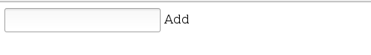](https://github.com/TelerikAcademy/JavaScript-UI-and-DOM/blob/master/Practical%20Exams/16-August-2016/task-1/sample-images/initial.png)

* Autocomplete string is "a"
  + Some suggestions are shown

[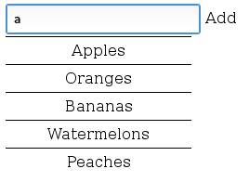](https://github.com/TelerikAcademy/JavaScript-UI-and-DOM/blob/master/Practical%20Exams/16-August-2016/task-1/sample-images/string-in-autocomplete-1.png)

* Autocomplete string is "ap"
  + Some suggestions are shown

[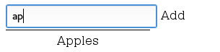](https://github.com/TelerikAcademy/JavaScript-UI-and-DOM/blob/master/Practical%20Exams/16-August-2016/task-1/sample-images/string-in-autocomplete-2.png)

* The autocomplete string becomes "Apples" after the "Apples" suggestion is clicked

[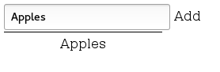](https://github.com/TelerikAcademy/JavaScript-UI-and-DOM/blob/master/Practical%20Exams/16-August-2016/task-1/sample-images/text-in-autocomplete-after-click-on-suggestion.png)

* No suggestion matches the autocomplete srtring "Pineapple"
  + No suggestions are shown

[https://github.com/TelerikAcademy/JavaScript-UI-and-DOM/raw/master/Practical%20Exams/16-August-2016/task-1/sample-images/no-suggestion-matches-autocomplete-string.png](https://github.com/TelerikAcademy/JavaScript-UI-and-DOM/blob/master/Practical%20Exams/16-August-2016/task-1/sample-images/no-suggestion-matches-autocomplete-string.png)

* After clicking the "Add" button the new suggestion "Pineapple" is added

[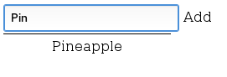](https://github.com/TelerikAcademy/JavaScript-UI-and-DOM/blob/master/Practical%20Exams/16-August-2016/task-1/sample-images/new-suggestion-added.png)

**Additional Requirements**

* You are **NOT** allowed to alter the HTML or the CSS in any way
  + Keep in mind, the tests use the original HTML and CSS
* Write all your code only in the task-1.js file
* Mandatory hide elements with display: none
* Use input event on the autocomplete <input />